NAATI Online Directory design testing quickstart and troubleshooting guide

Upon visiting the link, you should see the following screen:
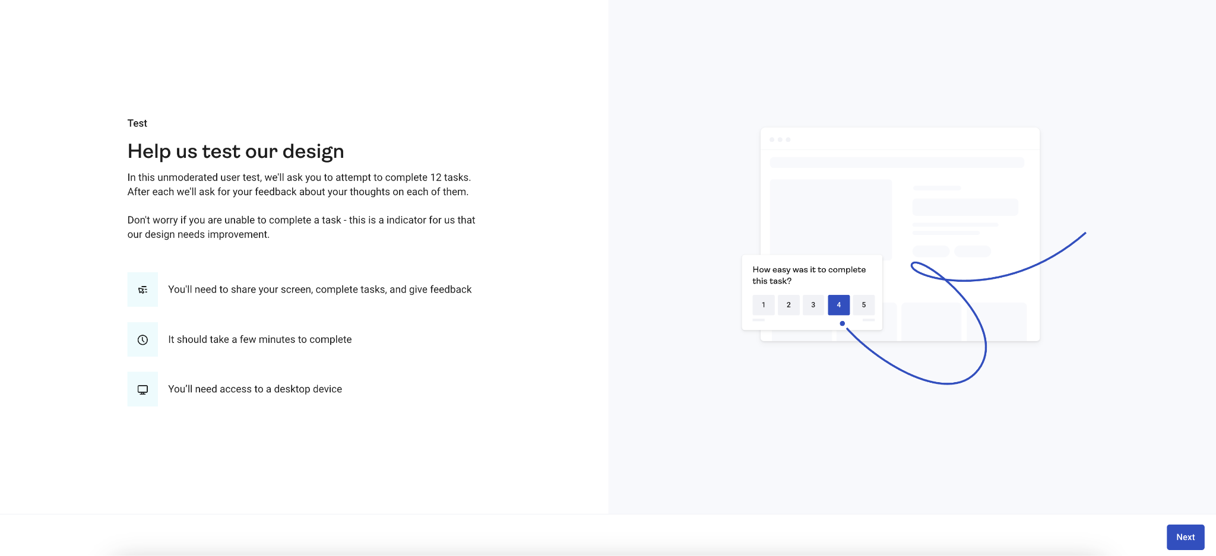

After clicking "Next", you'll be asked to enter your details:
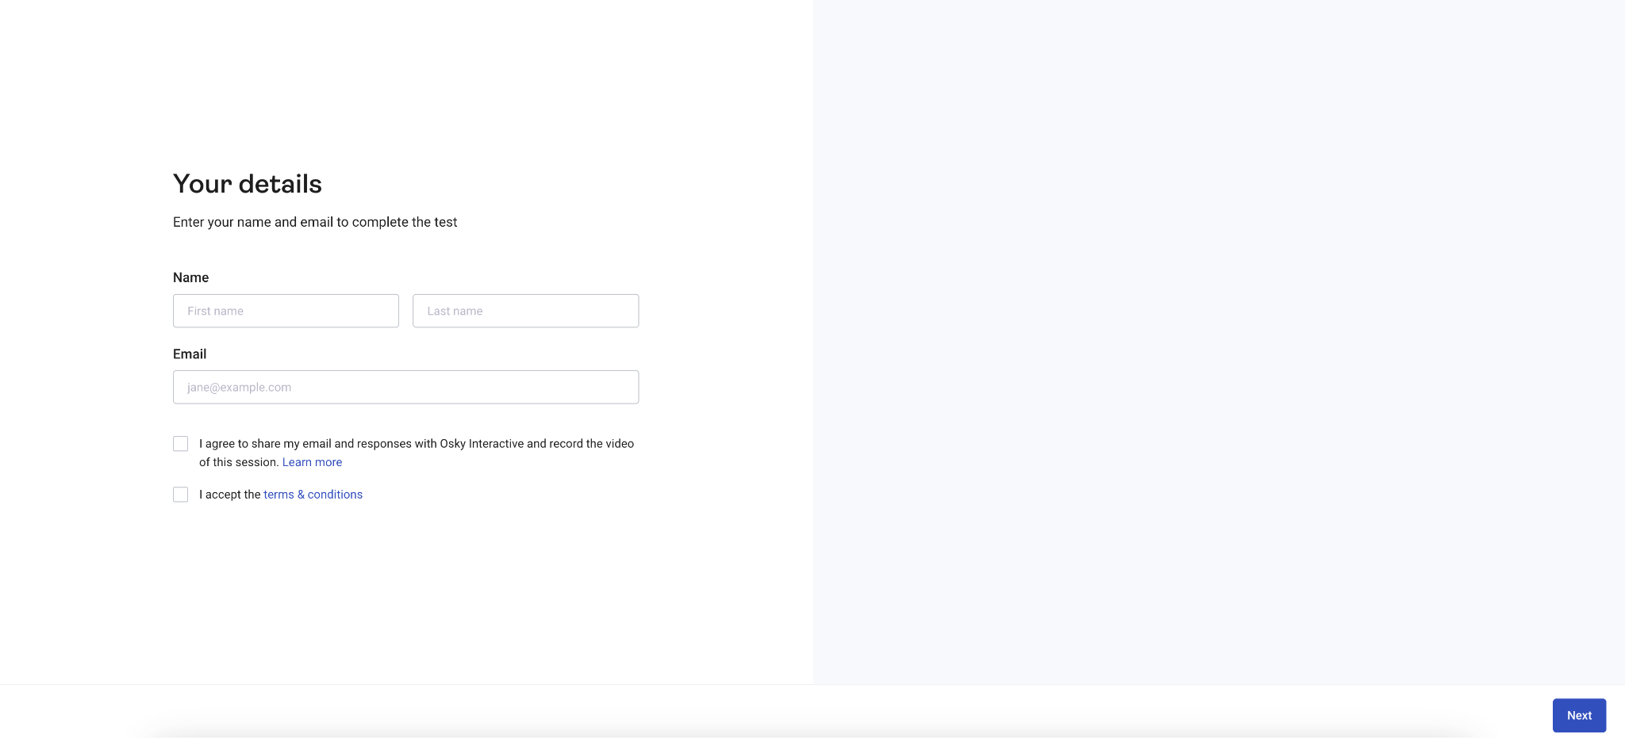

Next you'll be asked to set up screen sharing and a microphone.

Note: You may need to enable exceptions on your browser to allow these features on your browser.
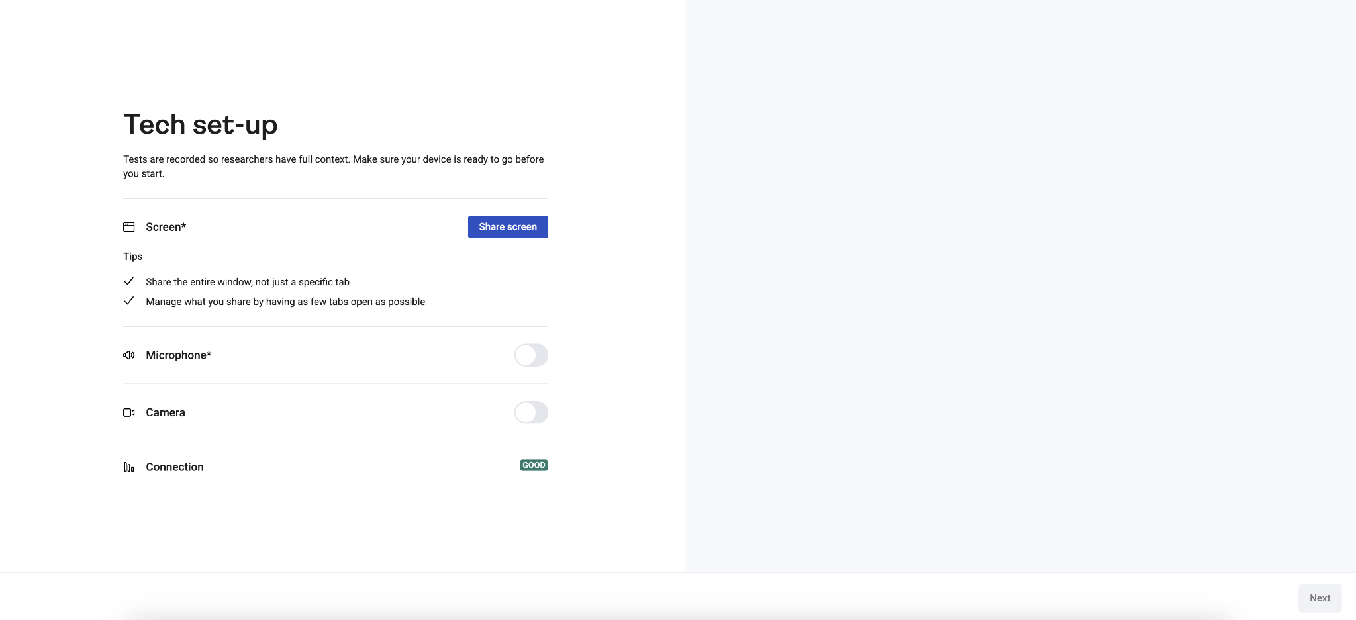

After set-up, on the next screen click "Get started" and it will open up the testing website.
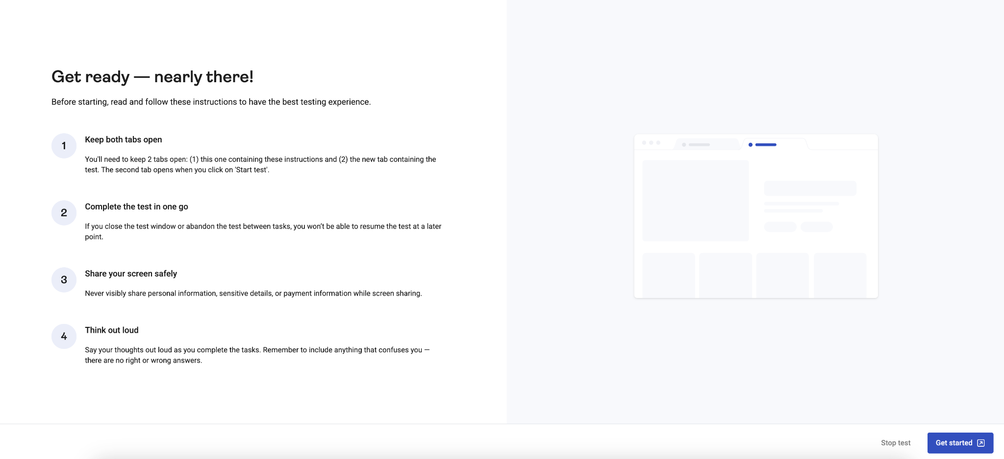

Note: If it doesn't, you may need to allow popups on your browser. If you need the "Get started" button to reappear, try refreshing the page or hitting your browser's back button to get back to the Tech set-up page and clicking "Next" again.
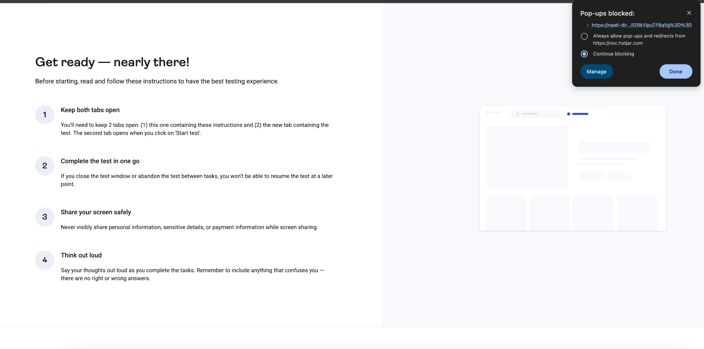

Upon opening the testing website, you should see the testing popup/overlay. In this case, you may begin the testing.
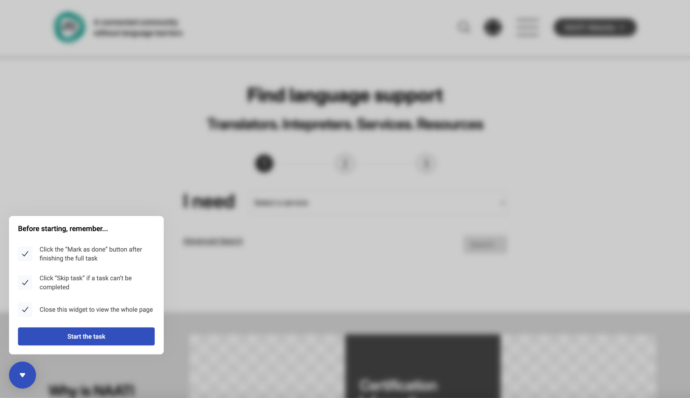

Note: If you do not see the testing popup/overlay, you may need to enable cross-site cookies on your browser for the duration of the testing.
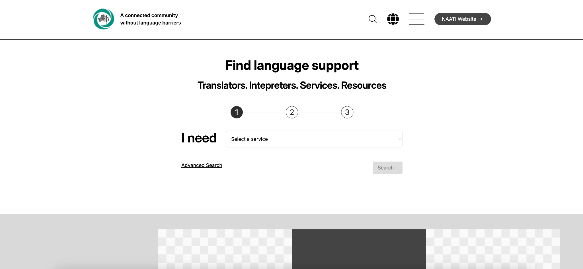

For example, in Chrome:
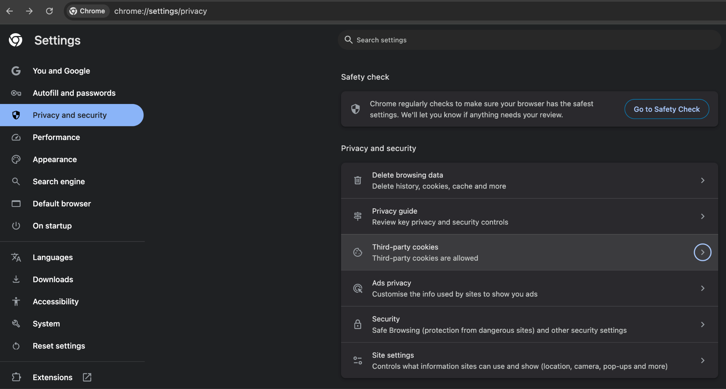

And in Firefox:
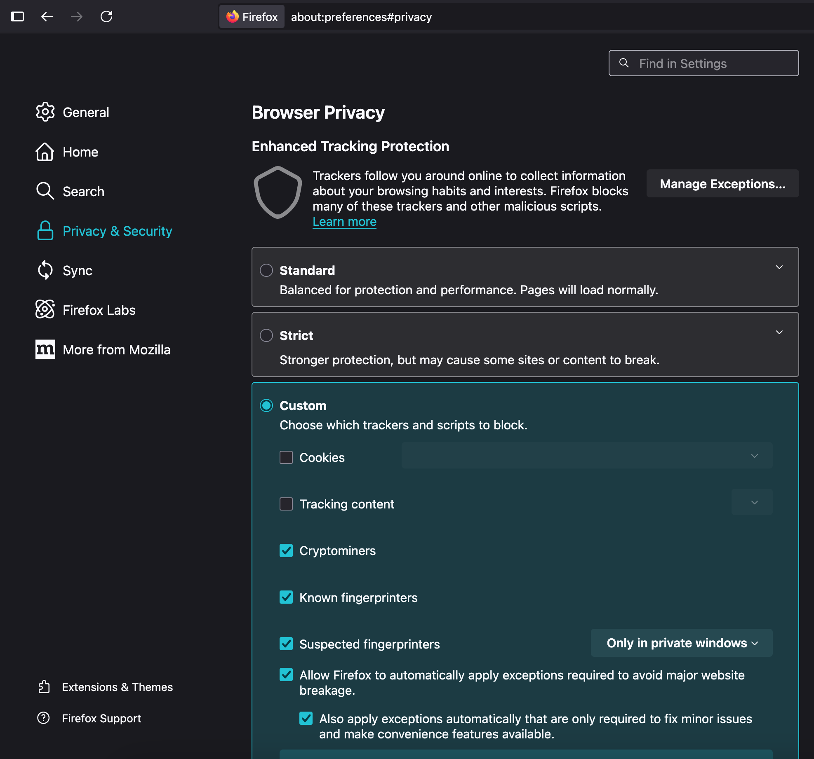

Make sure to refresh the testing page after enabling cookies.

